**\**

**COMSATS University Islamabad,Sahiwal Campus**

**Department of Computer Science**

|  |  |  |  |  |  |  |  |  |  |
| --- | --- | --- | --- | --- | --- | --- | --- | --- | --- |
| Course Title: | Fundamental of Pattern Recognition | | | | Course Code: | | CSC440 | Credit Hours: | 3(3,0) |
| Course Instructor: | Raheela Shahzadi | | | | Programme Name: | | FA17 BS(cS) | | |
| Semester: | 7th | Batch: |  | Section: |  | | Date: |  | |
| **Time Allowed:** | **60 Minutes** | | | | **Maximum Marks:** | | | **10** | |
| Student’s Name: |  | | | | Reg. No. | CIIT//SWL | | | |
| **Important Instructions / Guidelines:**  *Read the question paper carefully and answer the questions according to their statements.*  *Mobile phones are not allowed. Calculators must not have any data/equations etc. in their memory.* | | | | | | | | | |

**First Sessional**

**QNo.1.** Apply the backword propagation on following figure? The values of x1= 1,x2= 4, x3=5 and desired outputs are as o1=0.1, o2=.0.05. Implement neural network, apply sigmoid activation function, after that back propagate to adjust weights. Adjust w10 and w5 weight. [5]

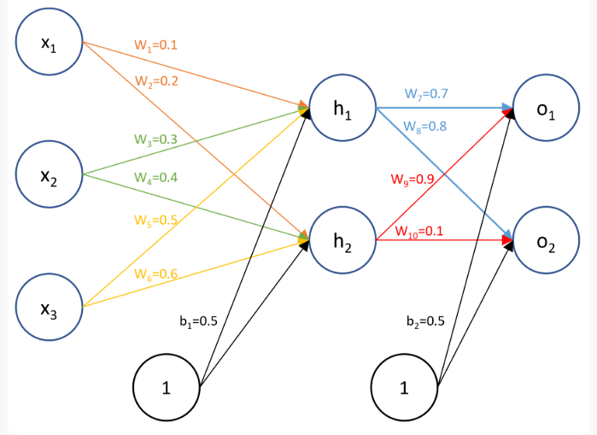

QNo.2. Apply the collaborative content recommender system on following dataset? [5]

|  |  |  |  |  |  |
| --- | --- | --- | --- | --- | --- |
|  | M1 | M2 | M3 | M4 | M5 |
| Customer 1 | 5 | 3 | 4 | ? | 4 |
| Customer 2 | 3 | 1 | 2 | 3 | 4 |
| Customer 3 | 4 | 3 | 4 | 3 | 5 |
| Customer 4 | 3 | 3 | 1 | 5 | 4 |
| Customer 5 | 1 | 5 | 5 | 2 | 1 |